Calculate Rewards Point :

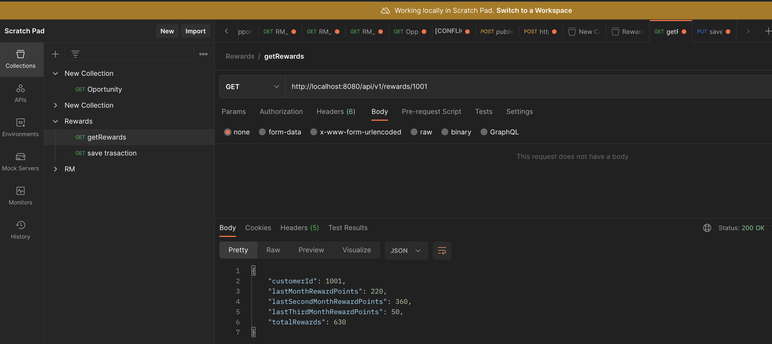

Create Transaction :

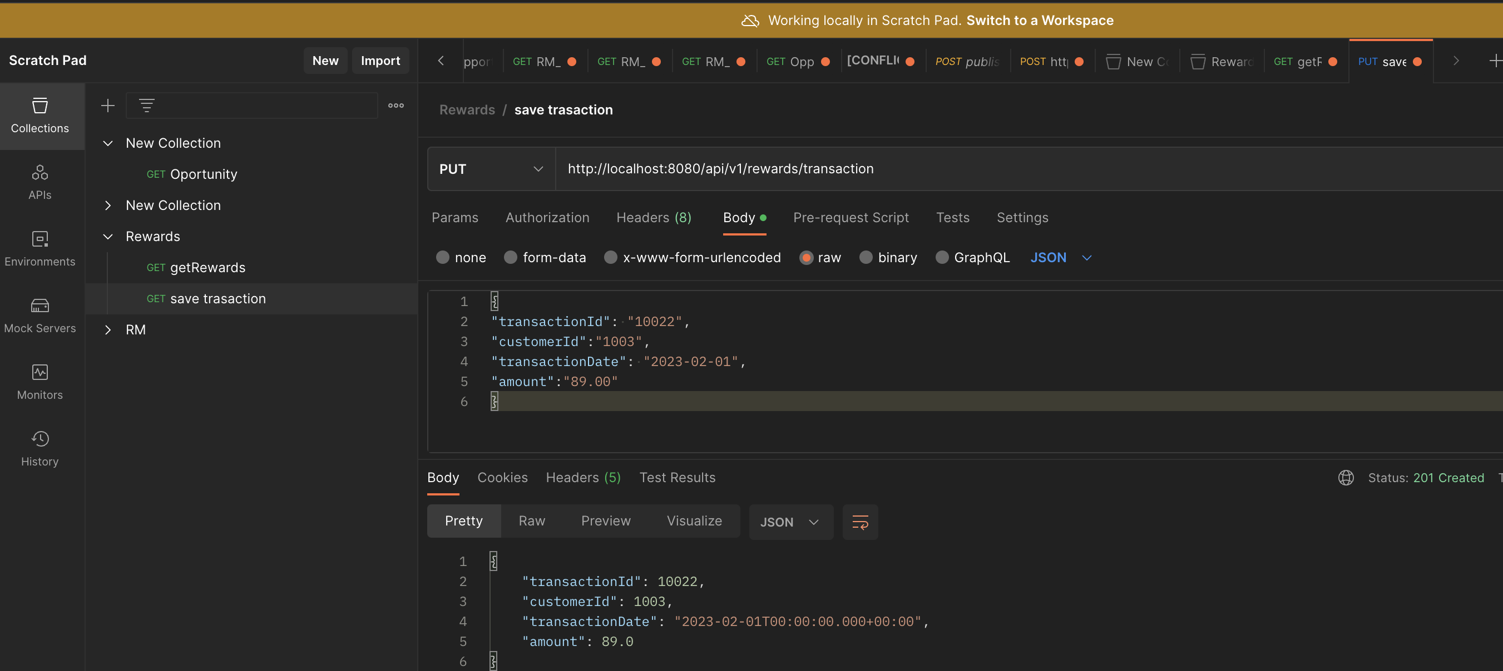

Delete Transaction :

